15-0; Function with pointer;

What will we learn in this module:

1. Learn more about pointer
2. Learn about Call by value and call by reference.
3. Array and pointer relationship
4. Array in function and how to work with string
5. Array in function how works when called by reference

15-1; Pointers in C

Pointer is a variable that contains address of another variable

int value = 100;

int \*ptr = &value;

(\*) value at operator, (&) address of operator

15-4; Array and Pointer

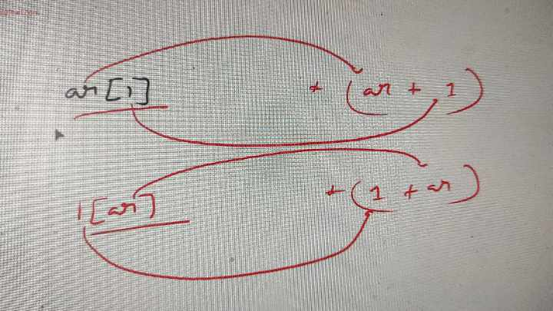

Is it really possible to right like this?